

**Holiday Smile Cookie Pre-Order Form**

**From November 18 - 24,** Tim Hortons Restaurant will be supporting the Calgary Food Bank and Tims Camps across Canada. **Guests who purchase a freshly baked Holiday Smile Cookie will be donating to these great causes with 100% of proceeds being donated!**

To pre-order Tim Hortons Holiday Smile Cookies, **complete this form and submit to your nearest Tim Hortons Restaurant** no less than 48 hours before your specified pick-up date & time. Payment can be submitted with this form or at pick up.

|  |  |  |
| --- | --- | --- |
| **Number of Boxes:** | Payment Total | *12 Cookies per box = $19.80* |

|  |  |  |
| --- | --- | --- |
| **Your Name:** |  | |
| **Address:** |  | |
|  | **Telephone:** | ( ) |

|  |  |  |  |
| --- | --- | --- | --- |
| **Pick Up Date:**  (choose one) | Nov. 18 ____  Nov. 19 ____  Nov. 20 ____  Nov. 21 ____  Nov. 22 ____  Nov. 23 ____  Nov. 24 ____ | **Pick Up Time**:  (please give a time of day you will pick up your order) |  |

**Thank you for supporting the**

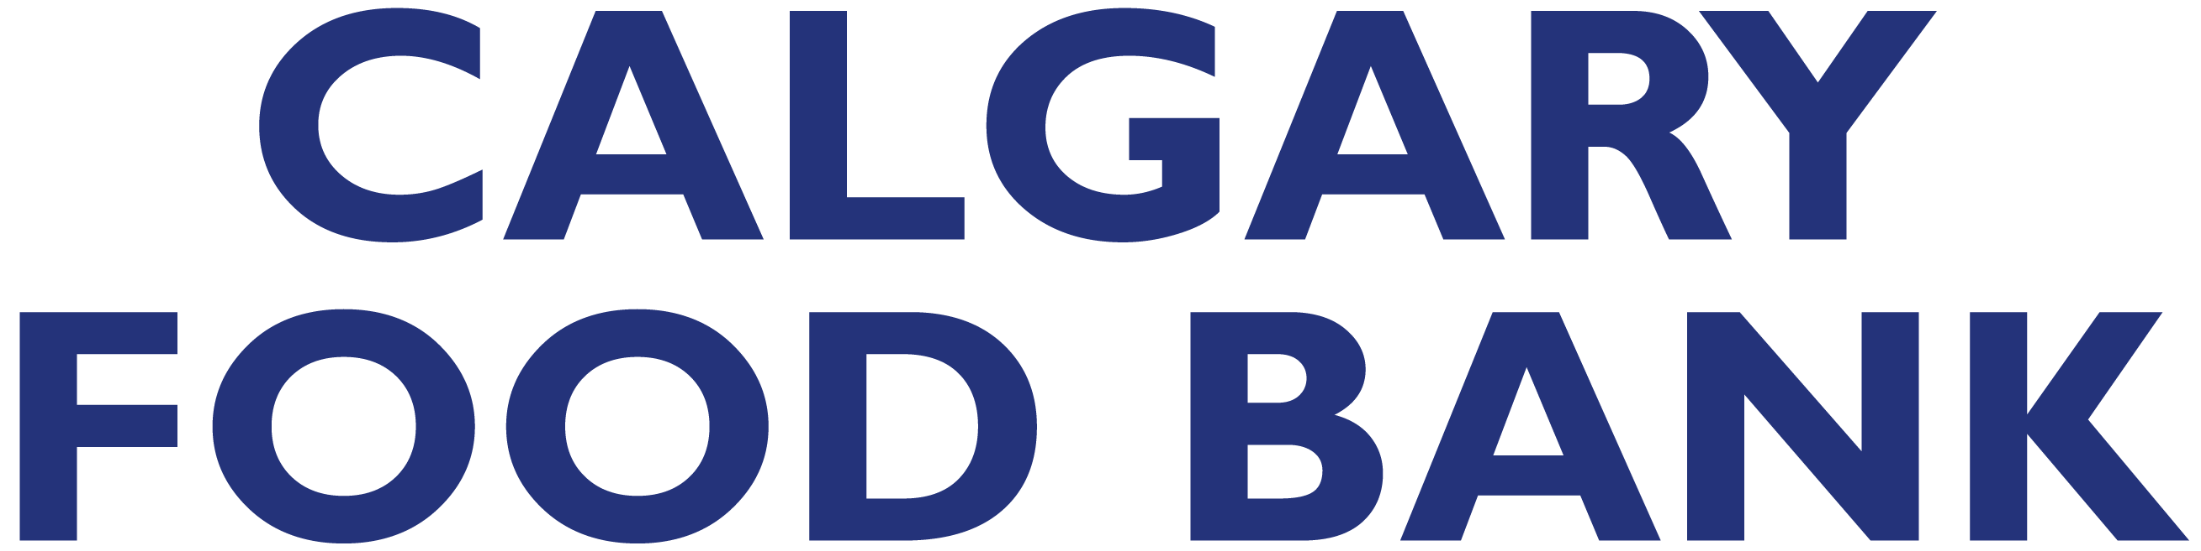

**By Community, For Community**